Fuzzy Logic System for Washing Machine Cycle Time
Name: Pranav Upadhyay
Registration No: 23FE10CSE00538

1. Introduction
Washing machines need to adjust their washing time based on how dirty the clothes are and how large the load is. In real life, these inputs are not exact values, but approximate (e.g., “slightly dirty”, “very dirty”).
Fuzzy logic helps handle such situations by using linguistic variables instead of exact numbers.
This project designs a fuzzy logic system that determines the washing machine cycle time using two inputs: dirt level and load size.

2. Problem Statement
To design a fuzzy logic system that determines washing cycle time based on:
- Dirt Level
- Load Size

3. Inputs and Output
Inputs:
- Dirt Level (Range: 0–10)
  - Low
  - Medium
  - High
- Load Size (Range: 0–10)
  - Small
  - Medium
  - Large
Output:
- Cycle Time (Range: 0–60 minutes)
  - Short
  - Medium
  - Long

4. Membership Functions
Dirt Level:
- Low → [0 0 4]
- Medium → [3 5 7]
- High → [6 10 10]
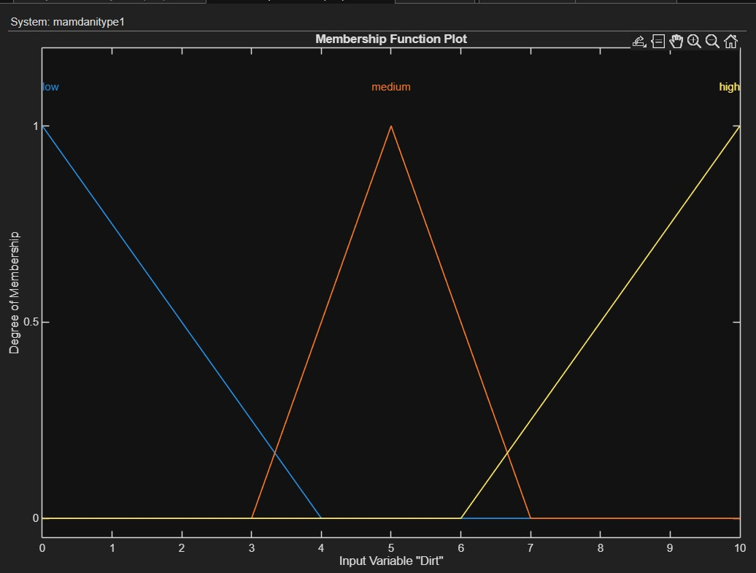

Load Size:
- Small → [0 0 4]
- Medium → [3 5 7]
- Large → [6 10 10]
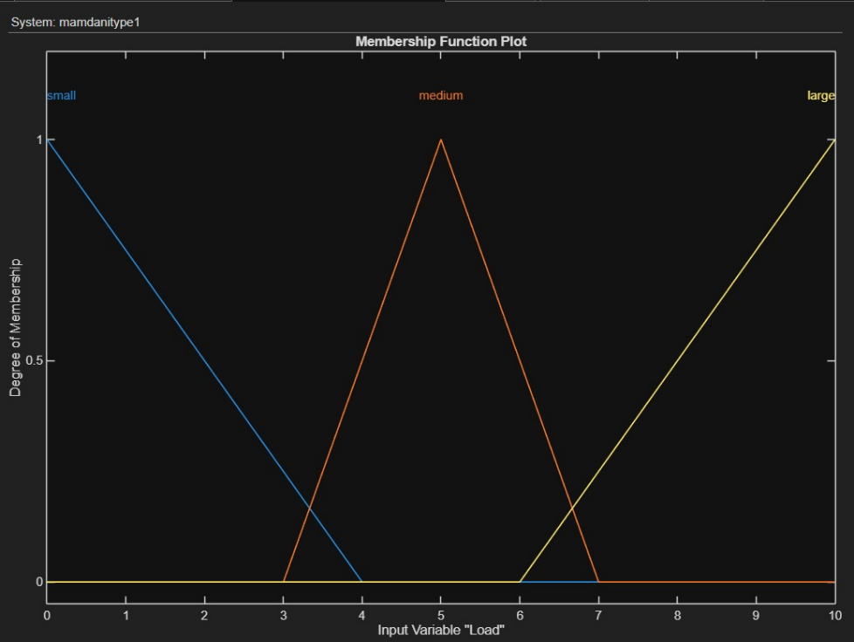

Cycle Time:
- Short → [0 0 20]
- Medium → [15 30 40]
- Long → [35 60 60]
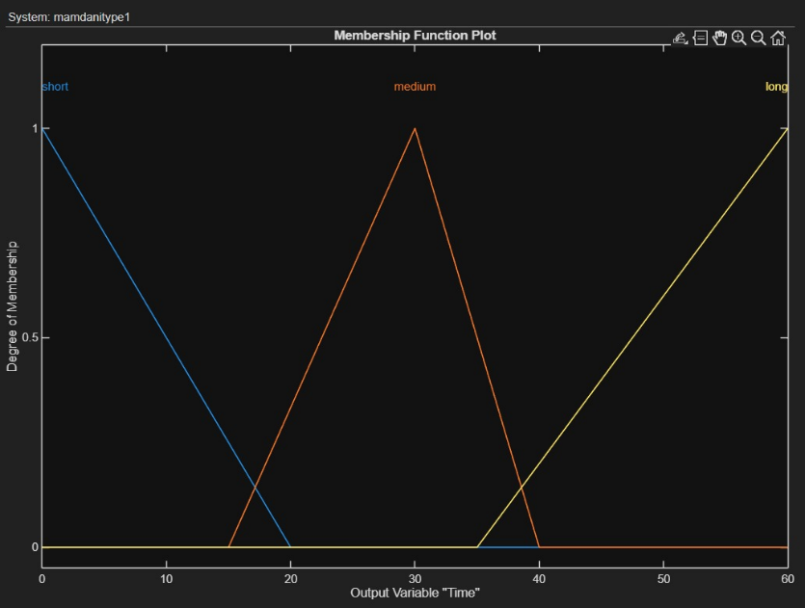

5. Rule Base
The following fuzzy rules were used:
- IF Dirt is Low AND Load is Small THEN Time is Short
- IF Dirt is Low AND Load is Medium THEN Time is Medium
- IF Dirt is Low AND Load is Large THEN Time is Medium
- IF Dirt is Medium AND Load is Small THEN Time is Medium
- IF Dirt is Medium AND Load is Large THEN Time is Long
- IF Dirt is High AND Load is Small THEN Time is Long
- IF Dirt is High AND Load is Medium THEN Time is Long
- IF Dirt is High AND Load is Large THEN Time is Long

6. Fuzzy Inference System
A Mamdani Type-1 Fuzzy Inference System was used.
Steps involved:
- Fuzzification – Converts input values into fuzzy values
- Rule Evaluation – Applies fuzzy rules
- Aggregation – Combines outputs of all rules
- Defuzzification – Converts fuzzy output into a crisp value

7. Results
Rule Viewer Output
The rule viewer shows how different rules are activated depending on input values.
For example:
- Dirt = 8
- Load = 7
→ Output: Long cycle time
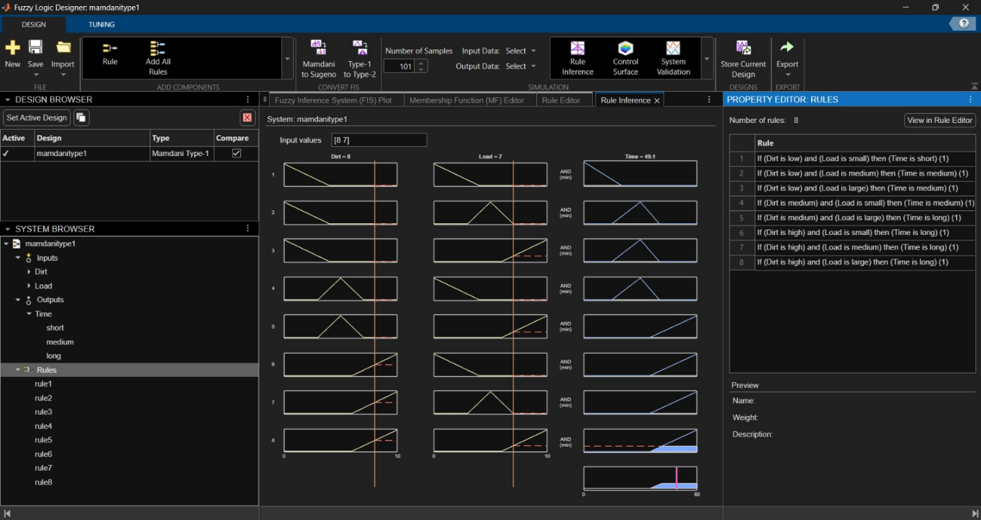

Surface Viewer Output
The surface viewer shows a 3D relationship between:
- Dirt Level
- Load Size
- Cycle Time
It clearly shows that:
- Higher dirt and load → longer cycle time
- Lower dirt and load → shorter cycle time
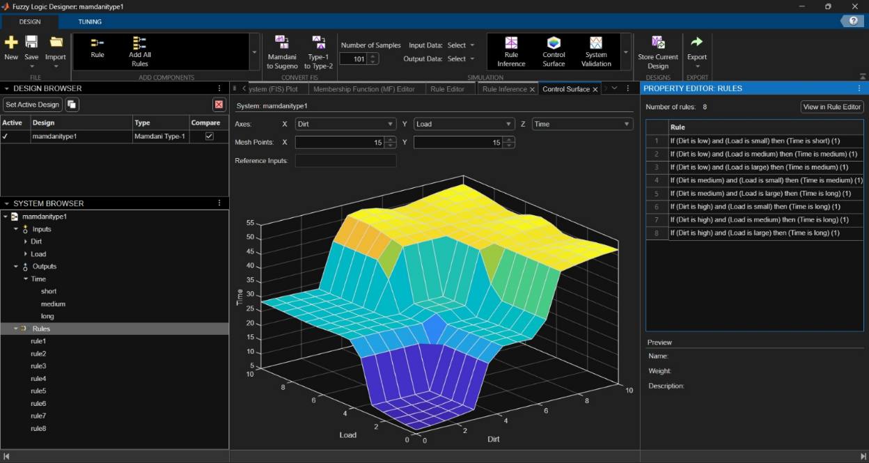

8. Conclusion
The fuzzy logic system successfully determines washing machine cycle time based on dirt level and load size.
It provides flexible and human-like decision-making, making it suitable for real-world applications like smart washing machines.

9. References
- MATLAB Fuzzy Logic Toolbox Documentation
- Lecture Notes on Fuzzy Logic

